Software Design Specification

CAMPUS BUS TRACKING APP

Project Code:

GROUP 2-CBTA

Internal Advisor:

TEAM MEMBERS

External Advisor:

DR.ILYAS

Project Manager:

RABIA HUSSAIN

Project Team:

Ufaq Shahzadi , Amraha Sidiqqa, Rabia Hussain

Submission Date:

_____________________
Project Manager’s Signature

Document Information

Category | Information
Customer | UOS – Department of Computer Science
Project | CAMPUS BUS TRACKING APP
Document | Software Design Specification
Document Version | 1.0
Identifier | SDS-CBTA-v1.0
Status | Draft
Author(s) | RABIA HUSSAIN , UFAQ SHAZADI , AMRAHA SIDIQQA
Approver(s) | PM
Issue Date | Nov. 15, 2025
Document Location | SARGODHA
Distribution | - RABIA HUSSAIN  - AMRAHA SIDDIQUE  - UFAQ SHAHZADI

Definition of Terms, Acronyms and Abbreviations
This section should provide the definitions of all terms, acronyms, and abbreviations required to interpret the terms used in the document properly.

Term | Description
ASP | Active Server Pages
DD | Design Specification
GPS | Global Positioning System
ETA | Estimated Time of Arrival
Admin | System administrator with management privileges
Passenger | User(either student or teacher ) who views bus routes and timings
Driver | Person responsible for driving campus buses
API | Application Programming Interface
Real-Time | Data updated instantly without delay
UML | Unified Modeling Language

Table of Contents

1. Introduction 4
1.1 Purpose of Document 4
1.2 Project Overview 4
1.3 Scope 4
2. Design Considerations 4
2.1 Assumptions and Dependencies 4
2.2 Risks and Volatile Areas 4
3. System Architecture 4
3.1 System Level Architecture 4
3.2 Sub-System / Component / Module Level Architecture 5
3.3 Sub-Component / Sub-Module Level Architecture (1…n) 5
4. Design Strategies 5
4.1 Strategy 1…n 5
5. Detailed System Design 5
6. References 6
7. Appendices 6

Introduction

  - Purpose of Document
This document describes the design of the Campus Bus Tracking system. It is intended for developers, analysts, project managers, testers and campus administrations involved in the project. This system is designed using Object Oriented design methodology to ensure a modular and maintainable structure.

  - Project Overview
The campus bus tracking system is designed to track campus buses and provide real-time location and information to users. It helps passengers plan their travel and allow administrators to manage buses and routes. The system is developed using an object-oriented design approach for maintainable solution.

  - Scope

The system will do:
- Track the buses in real time and show their current location.
- Provide estimated arrival times for passengers.
- Allow passengers to view bus routes.
- Enable administrators to manage buses, routes and records of buses.
The system will not do:
- It will not handle payment and ticketing form passengers.
- It will not control or drive the buses automatically.

Design Considerations
- System performance: Ensuring real time tracking updates and quick response for passengers.
- Scalability: Designing the system to handle an increasing number of buses, routes and passengers.
- Usability: Making the system easy to use for passengers and administrators.
- Reliability: Ensuring the system works accurately, without errors.
- Integration: Ensuring the system can work with GPS devices and mobile apps.
- Maintenance: Designing the system so that future updates, bug fixes and feature additions are easy to implement.

  - Assumptions and Dependencies
Assumptions:
- All buses are provided with GPS devices.
- Reliable internet connectivity is available for real time tracking.
- Users have access to mobile apps.
- Buses, routes and data provided by the administrator is accurate and up-to-date.
Dependencies:
- The system depends on GPS devices to provide location data for buses.
- Accurate routes information must be maintained by administrator.
- External services must be available and functioning.

  - Risks and Volatile Areas
Risks:
- Technology changes: Updates or changes in GPS devices or mobile platforms.
- New requirements: Additional features like payments systems and route optimization could be added later.
- Network reliability: Unstable internet or network issues may affect real time tracking.
- Data accuracy: Incorrect or outdated buses or routes information can impact system performance.
- User behavior: Increased number of user may affect system scalability.
Design consideration to handle risk:
- Modular design using object oriented principles to make adding or updating features easily.
- Use of standard interface to integrate with third party services.
- Implement error handling mechanism for network and data failures.
- Scalable architecture to handle increasing number of users and buses.

System Architecture

The campus bus tracking system is designed to provide real time monitoring and management of buses. This system is divided into following components:
Routes: Stores all bus routes, providing essential route information to passengers and drivers
Buses: Contains details of buses including registration, capacity, and assigned routes, managed by the admin.
Location: Tracks real-time GPS positions of buses and updates passengers.
Monitoring / ETA: Calculates estimated arrival times and allows the admin to monitor bus.
Reports: Generates delays and route efficiency insights, accessible to the admin for analysis.
Bus Entity: Represents buses, ensuring proper mapping of buses to routes and schedules.

Interaction with Users
Passengers: Access real-time bus location, ETA, and route information through the mobile app.
Drivers: Receive assigned routes and bus details, and update status while following real-time route guidance.
Admin: Manages buses, routes, and driver assignments, while monitoring performance and generating reports.
• 3.1 System Level Architecture
The architecture should decompose the system at a top level in a way that provides a foundation for more detailed design work. The architecture discusses relationships and roles of system elements (subsystems, components, modules, etc.), but does not provide internal details. Areas for consideration are:
- System decomposition into elements
- The relationship between the elements
- Interfaces to external systems
- Major physical design issues such as where elements will execute
- Global design strategies such as error handling

NOTE: You may use appropriate UML diagrams (Package and Deployment diagrams) to document the overall system architecture. Similarly you can describe the top-level decomposition of the system using Component diagrams.

- System Level Architecture Description :

The Campus Bus Tracking System follows a *three-tier architecture* consisting of:

• Presentation Layer
Mobile application and web dashboard used by passengers, drivers, and administrators.
• Application Layer
Handles business logic such as location processing, ETA calculation, route management, and reporting.
• Data Layer
Stores bus details, routes, GPS coordinates, user data, and historical records.

- External Interfaces:
• GPS devices installed on buses
• Internet services for real-time data transfer
- Error Handling:
• Handles GPS signal loss
• Network failure recovery
• Invalid data input handling

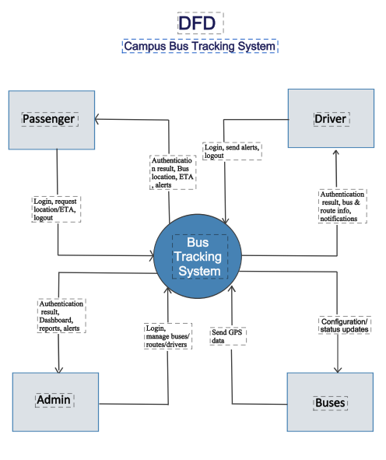

3.2 Sub-System / Component / Module Level Architecture
Identify the sub-systems, component or modules of your overall software system and provide their diagrammatic view using appropriate detailed architecture diagram presenting how the system is further divided into sub systems, components and modules and the relationships and interactions between them.

The system is divided into the following major components:

1. User Management Module
Manages passengers, drivers, and admin authentication and roles.

2. Bus Management Module
Stores bus details, capacity, registration, and assigned routes.

3. Route Management Module
Handles route creation, modification, and assignment.

4. Location Tracking Module
Receives GPS data and updates bus positions in real time.

5. ETA & Monitoring Module
Calculates estimated arrival times and monitors bus performance.

6. Reporting Module
Generates reports on delays, route efficiency, and usage.

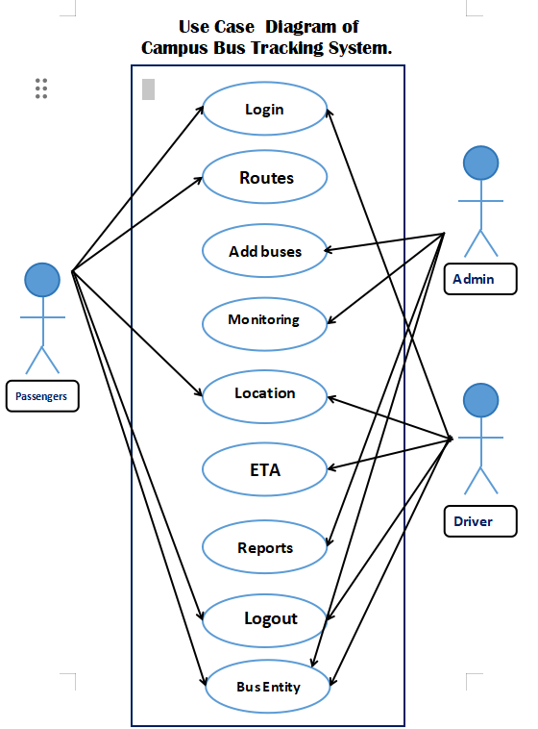

3.3 Sub-Component / Sub-Module Level Architecture (1…n)
Identify all the sub components or sub modules (if any) of the already identified modules and components. Provide their diagrammatic view using appropriate detailed architecture diagram presenting how those sub systems, modules and components are further divided into sub components and sub modules and how they interact with each other.

Location Tracking Module Sub-Components:
• GPS Data Receiver
• Location Validator
• Location Updater

User Management Module Sub-Components:
• Login Handler
• Role Manager
• Access Control

ETA Module Sub-Components:
• Distance Calculator
• Speed Analyzer
• ETA Generator

Each sub-module interacts through defined interfaces ensuring modularity and reusability.

Design Strategies
Describe the design strategies or decisions that impact the overall organization of the system and its high-level structures. This information should provide the reader with insights into the key abstractions and mechanisms used in the system architecture.

  - Strategy 1…n

Strategy 1: Modular Design
- Reasoning: The system is divided into components like Routes, Buses, Bus Entity, Location, Monitoring/ETA, Reports, and User Interface.
- Benefits: Makes maintenance and future updates easier.
- Trade-offs: Requires clear interfaces between modules.
- Considerations: Supports system reuse and future enhancements.

Strategy 2: Real-Time Processing
- Reasoning: Bus locations and ETAs are updated continuously.
- Benefits: Passengers and drivers get accurate live information.
- Trade-offs: Increases server load and complexity.
- Considerations: Requires proper concurrency and synchronization to handle multiple updates.

Strategy 3: User-Friendly Interface
- Reasoning: Simple dashboards for admin and easy-to-use apps for passengers and drivers.
- Benefits: Improves usability and quick access to data.
- Trade-offs: Must balance simplicity with enough information.
- Considerations: Supports user interface for different users.

Detailed System Design
A detailed design should include the following:

- Detailed class diagram along with a detailed description of all attributes, functions or methods specifying interactions between different classes/modules.
- Detailed Sequence diagram with parameter list
- State Transition Diagram
- Logical data model (E/R model)
- Physical data models
- Detailed GUIs

5.1 Class Diagram

Main Classes:
• Bus
• Route
• User
• Passenger
• Driver
• Admin
• Location
• Report
Example Attributes:

Bus:
- busID
- registrationNumber
- capacity
- currentLocation

Example Methods:

- updateLocation()
- assignRoute()
- getETA()

5.2 Sequence Diagram

Scenario: Passenger checks bus location

Steps:

1. Passenger requests bus location
2. System fetches GPS data
3. ETA is calculated
4. Location & ETA displayed to passenger

5.3 State Transition Diagram

Bus States:
• Idle
• On Route
• Delayed
• Completed
Transitions occur based on route assignment and GPS updates.

5.4 Logical Data Model (ER Diagram)

Entities:
• Bus
• Route
• User
• Location
• Report

Relationships:
• One Route → Many Buses
• One Bus → Many Locations

5.5 Physical Data Model

Tables:
• BUS
• ROUTE
• USER
• LOCATION
• REPORT

Includes primary keys, foreign keys, and constraints.

5.6 GUI Design

Passenger App:
• View bus location
• View ETA
• View routes

Admin Dashboard:
• Manage buses
• Manage routes
• Generate reports

Screenshots or mockups required.

References
This section should provide a complete list of all documents referenced at specific point in time. Each document should be identified by title, report number (if applicable), date, and publishing organization. Specify the sources from which the references can be obtained (This section is like the bibliography in a published book).

Ref. No. | Document Title | Date of Release/ Publication | Document Source
CBTA-2025-SRS | SRS Document | Oct , 2025 | https://github.com/RABIA-HUSSAIN/SRS-PROJECT-GROUP-2-Campus-Bus-Tracking-App
CBTA-2025-DFD | DFD | 5 Nov, 2025 | https://github.com/RABIA-HUSSAIN/SRS-PROJECT-GROUP-2-Campus-Bus-Tracking-App
CBTA-2025-Use Case | Use Case | 15 Nov, 2025 | https://github.com/RABIA-HUSSAIN/SRS-PROJECT-GROUP-2-Campus-Bus-Tracking-App

Appendices
Include supporting detail that would be too distracting to include in the main body of the document.

Appendix A: UML Diagrams
Appendix B: Database Schema
Appendix C: Sample GUI Screens
Appendix D: API Endpoints Description

